EXPERIMENT 5
Arya Basak
23MS233

AIM:
Study of 555 Timer IC as Astable multivibrator with different frequency.
ELECTRONIC COMPONENTS REQUIRED:
- Power supply, 1 No: +15 V
- Registers: 1 k, 10 k, 100 k, and 1 M
- Capacitors: 0.001µF, 0.01µF, 0.1µF, 1µF, and 10µF
- IC 555: 1 No
- LED, 1 Nos
- Breadboard = 1 No
- CRO = 1 No
- Single strand wires = 4 - 5 Nos.

THEORY:
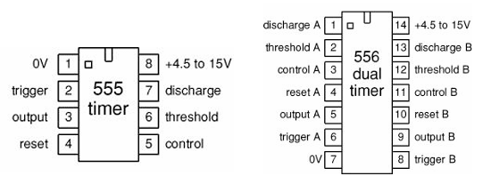
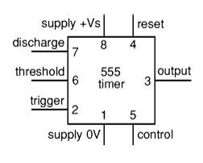
The 8-pin 555 timer is one of the most useful ICs ever made and it is used in many projects. A popular version is the NE555 and this is suitable in most cases where a '555 timer' is specified. The 556 is a dual version of the 555 housed in a 14-pin package. The two timers (A and B) share the same power supply pins. The below circuit diagrams show a 555, but they could all be adapted to use one half of a 556.
Figure 1: Circuit Symbol of 555 timer
Figure 2: Actual pin configurations of 555 and 556 timers

Low power versions of the 555 are made, such as the ICM7555, but these should only be used when specified (to increase battery life) because their maximum output current of about 20mA (with a 9V supply) is too low for many standard 555 circuits. The ICM7555 has the same pin arrangement as a standard 555.
The circuit symbol for a 555 (and 556) is a box with the pins arranged to suit the circuit diagram: for example, 555 pin 8 at the top for the +V_{s} supply, 555 pin 3 output on the right. Usually just the pin numbers are used and they are not labelled with their function.
The 555 and 556 can be used with a supply voltage (V_{s}) in the range 4.5 to 15V (18V absolute maximum). Standard 555 and 556 ICs create a significant 'glitch' on the supply when their output changes state. This is rarely a problem in simple circuits with no other ICs, but in more complex circuits a smoothing capacitor (e.g., 100µF) should be connected across the +V_{s} and 0V supply near the 555 or 556. The input and output pin functions are described briefly below and there are fuller explanations covering the various circuits:
- Astable - producing a square wave
- Monostable - producing a single pulse when triggered

Inputs of 555/556:
- Trigger input: when < 1/3 V_{s} ('active low') this makes the output high (+V_{s}). It monitors the discharging of the timing capacitor in an astable circuit. It has a high input impedance > 2MΩ.
- Threshold input: when > 2/3 V_{s} ('active high') this makes the output low (0V)*. It monitors the charging of the timing capacitor in astable and monostable circuits. It has a high input impedance > 10MΩ.
*(provided the trigger input is > 1/3 V_{s}, otherwise the trigger input will override the threshold input and hold the output high (+V_{s})).
- Reset input: When less than about 0.7V ('active low') this makes the output low (0V), overriding other inputs. When not required it should be connected to +V_{s}. It has an input impedance of about 10kΩ.
- Control input: This can be used to adjust the threshold voltage which is set internally to be 2/3 V_{s}. Usually this function is not required and the control input is connected to 0V with a 0.01µF capacitor to eliminate electrical noise. It can be left unconnected if noise is not a problem.
- The discharge pin is not an input, but it is listed here for convenience. It is connected to 0V when the timer output is low and is used to discharge the timing capacitor in astable and monostable circuits.

555/556 Astable:
An astable circuit produces a 'square wave'. This is a digital waveform with sharp transitions between low (0V) and high (+V_{s}). Note that the durations of the low and high states may be different. The circuit is called an astable because it is not stable in any state - the output is continually changing between 'low' and 'high'. The time period (T) of the square wave is the time for one complete cycle, but it is usually better to consider frequency (f) which is the number of cycles per second.
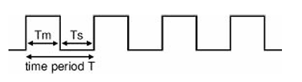
T = 0.7 × (R₁ + 2R₂) × C₁
f = 1.4/[(R₁ + 2R₂) × C₁]
Figure 3: 555 astable square-wave output
T = time period in seconds (s)
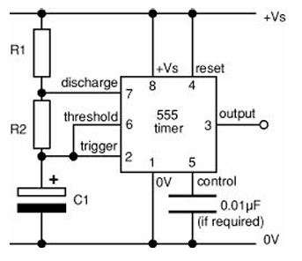
f = frequency in hertz (Hz)
Figure 4: 555 astable circuit
R₁ = resistance in ohms (Ω)
R₂ = resistance in ohms (Ω)
C₁ = capacitance in farads (F)

The time period can be split into two parts: T = T_{m} + T_{s}
- Mark time (output high): T_{m} = 0.7 × (R₁ + R₂) × C₁
- Space time (output low): T_{s} = 0.7 × R₂ × C₁

Many circuits require T_{m} and T_{s} to be almost equal; this is achieved if R₂ is much larger than R₁.
For a standard astable circuit T_{m} cannot be less than T_{s}, but this is not too restricting because the output can both sink and source current. For example, an LED can be made to flash briefly with long gaps by connecting it (with its resistor) between +V_{s} and the output. This way the LED is on during T_{s}, so brief flashes are achieved with R₁ larger than R₂, making T_{s} short and T_{m} long. If T_{m} must be less than T_{s}, a diode can be added to the circuit as explained under duty cycle below.

Choosing R₁, R₂ and C₁:
R₁ and R₂ should be in the range 1kΩ to 1MΩ. It is best to choose C₁ first because capacitors are available in just a few values.
- Choose C₁ to suit the frequency range you require (use the table as a guide).
- Choose R₂ to give the frequency (f) you require. Assume that R₁ is much smaller than R₂ (so that T_{m} and T_{s} are almost equal), then you can use:
$$R_{2}=\frac{0⋅7}{f×C_{1}}$$

- Choose R₁ to be about a tenth of R₂ (1kΩ min.) unless you want the mark time T_{m} to be significantly longer than the space time T_{s}.
- If you wish to use a variable resistor it is best to make it R₂.
- If R₁ is variable it must have a fixed resistor of at least 1kΩ in series (this is not required for R₂ if it is variable).

OBSERVATIONS:
Table 1: 555 Astable Frequencies
Sl. No. | C₁ (µF) | R₁ (kΩ) | R₂ (kΩ) | f (Theory) | T_{m} (Expt) | T_{s} (Expt) | T = T_{m} + T_{s} | f (Expt) | % Error
1 | 0.001 | 1 | 10 | 66.7 kHz | 8.6 µs | 7.9 µs | 16.5 µs | 60.7 kHz | 9
2 | 0.001 | 10 | 100 | 6.67 kHz | 66.8 µs | 64.8 µs | 131.6 µs | 7.6 kHz | 14
3 | 0.001 | 100 | 1000 | 667 Hz | 636 µs | 620 µs | 1.256 ms | 796.18 Hz | 19
1 | 0.01 | 1 | 10 | 6.67 kHz | 71.6 µs | 66.8 µs | 138.4 µs | 7.23 kHz | 8
2 | 0.01 | 10 | 100 | 667 Hz | 664 µs | 652 µs | 1.316 ms | 762.2 Hz | 14
3 | 0.01 | 100 | 1000 | 66.7 Hz | 6.76 ms | 6.48 ms | 13.2 ms | 75.76 Hz | 14
1 | 0.1 | 1 | 10 | 667 Hz | 524 µs | 530 µs | 1.054 ms | 948.77 Hz | 42
2 | 0.1 | 10 | 100 | 66.7 Hz | 4.7 ms | 4.76 ms | 9.46 ms | 107.07 Hz | 61
3 | 0.1 | 100 | 1000 | 6.67 Hz | 60.3 ms | 57.4 ms | 118 ms | 8.49 Hz | 27
1 | 1 | 1 | 10 | 66.7 Hz | 7.16 ms | 6.68 ms | 13.840 ms | 72.46 Hz | 9
2 | 1 | 10 | 100 | 6.67 Hz | 65.8 ms | 62.6 ms | 128.4 ms | 7.78 Hz | 17
3 | 1 | 100 | 1000 | 0.67 Hz | 676 ms | 632 ms | 1.31 s | 0.77 Hz | 15
1 | 10 | 1 | 10 | 6.67 Hz | 74.4 ms | 69.8 ms | 144.2 ms | 7.37 Hz | 10
2 | 10 | 10 | 100 | 0.67 Hz | 676 ms | 662 ms | 1.34 s | 0.75 Hz | 12
3 | 10 | 100 | 1000 | 0.067 Hz | 7.62 s | 6.86 s | 14.48 s | 0.07 Hz | 0

CONCLUSION:
As can be seen from the above data table, the experimental frequency and the theoretical frequency for different combinations of R₁, R₂ and C₁ are close to each other. Hence, the formula for frequency of 555 astable multivibrator is verified.

SOURCES OF ERROR:
- Resistors (R₁, R₂) typically have ±5% or ±1% tolerance. Capacitors can have large tolerances (±10% to ±20% or more). Since frequency depends on $R$and $C$, small variations can cause noticeable errors.
- Real capacitors have leakage current and equivalent series resistance (ESR), affecting charging time.
- Resistance and capacitance values vary with temperature. The IC itself may also behave slightly differently at different temperatures.
- Resistance in wires and breadboard connections and loose connections can cause unstable output.
- Readings may not be taken properly from the oscilloscope/multimeter.

